**PRAKTIKUM SISTEM DATABASES II**

**(Tugas 5)**



**Disusun Oleh:**

Prames Ray Lapian - 140810210059

**PROGRAM STUDI S-1 TEKNIK INFORMATIKA**

**FAKULTAS MATEMATIKA DAN ILMU PENGETAHUAN ALAM**

**UNIVERSITAS PADJADJARAN**

**JATINANGOR**

**2022**

Normalisasi tabel berikut ke 1NF, 2NF, dan 3NF!

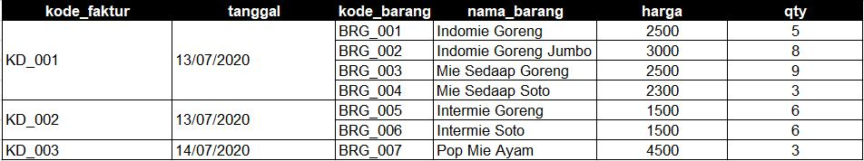

1. 1NF

Tabel Barang

|  |  |  |  |  |  |
| --- | --- | --- | --- | --- | --- |
| Kode_faktur | Tanggal | Kode_barang | Nama_barang | Harga | Qty |
| KD_001 | 13/07/2020 | BRG_001 | Indomie Goreng | 2500 | 5 |
| KD_001 | 13/07/2020 | BRG_002 | Indomie Goreng Jumbo | 3000 | 8 |
| KD_001 | 13/07/2020 | BRG_003 | Mie Sedap Goreng | 2500 | 9 |
| KD_001 | 13/07/2020 | BRG_004 | Mie Sedap Soto | 2300 | 3 |
| KD_002 | 13/07/2020 | BRG_005 | Intermie Goreng | 1500 | 6 |
| KD_002 | 13/07/2020 | BRG_006 | Intermie Soto | 1500 | 6 |
| KD_003 | 14/07/2020 | BRG_007 | Pop Mie Ayam | 4500 | 3 |

1. 2NF

Tabel Faktur

|  |  |  |  |
| --- | --- | --- | --- |
| Kode_faktur | Tanggal | Kode_barang | Qty |
| KD_001 | 13/07/2020 | BRG_001 | 5 |
| KD_001 | 13/07/2020 | BRG_002 | 8 |
| KD_001 | 13/07/2020 | BRG_003 | 9 |
| KD_001 | 13/07/2020 | BRG_004 | 3 |
| KD_002 | 13/07/2020 | BRG_005 | 6 |
| KD_002 | 13/07/2020 | BRG_006 | 6 |
| KD_003 | 14/07/2020 | BRG_007 | 3 |

Tabel Barang

|  |  |  |
| --- | --- | --- |
| Kode_barang | Nama_barang | Harga |
| BRG_001 | Indomie Goreng | 2500 |
| BRG_002 | Indomie Goreng Jumbo | 3000 |
| BRG_003 | Mie Sedap Goreng | 2500 |
| BRG_004 | Mie Sedap Soto | 2300 |
| BRG_005 | Intermie Goreng | 1500 |
| BRG_006 | Intermie Soto | 1500 |
| BRG_007 | Pop Mie Ayam | 4500 |

1. 3NF

Tabel Barang

|  |  |  |
| --- | --- | --- |
| Kode_barang | Nama_barang | Harga |
| BRG_001 | Indomie Goreng | 2500 |
| BRG_002 | Indomie Goreng Jumbo | 3000 |
| BRG_003 | Mie Sedap Goreng | 2500 |
| BRG_004 | Mie Sedap Soto | 2300 |
| BRG_005 | Intermie Goreng | 1500 |
| BRG_006 | Intermie Soto | 1500 |
| BRG_007 | Pop Mie Ayam | 4500 |

Tabel Faktur

|  |  |
| --- | --- |
| Kode_faktur | Tanggal |
| KD_001 | 13/07/2020 |
| KD_001 | 13/07/2020 |
| KD_001 | 13/07/2020 |
| KD_001 | 13/07/2020 |
| KD_002 | 13/07/2020 |
| KD_002 | 13/07/2020 |
| KD_003 | 14/07/2020 |

Tabel Detail Barang

|  |  |  |  |
| --- | --- | --- | --- |
| Kode_barang | Nama_barang | Qty | Harga |
| BRG_001 | Indomie Goreng | 5 | 2500 |
| BRG_002 | Indomie Goreng Jumbo | 8 | 3000 |
| BRG_003 | Mie Sedap Goreng | 9 | 2500 |
| BRG_004 | Mie Sedap Soto | 3 | 2300 |
| BRG_005 | Intermie Goreng | 6 | 1500 |
| BRG_006 | Intermie Soto | 6 | 1500 |
| BRG_007 | Pop Mie Ayam | 3 | 4500 |